

Ministry/Agency Name

[Complete file/properties to populate fields on this page and in the document headers]

Project Name

Project #:

Business Requirements Document (BRD) Template

**Prepared by:** Bhiral Dave

**Prepared for:**

**Date Submitted:** 23/12/23

**Project Sponsor:** Project Sponsor's Name

**Client Acceptor:**

**Project Manager:**

**Document Number:**

**Security Classification: Low**

**Version:** 0.1

**Last Updated:** 19/11/2023

**Creation Date:** 19/11/2023

# Table of Contents

Table of Contents 2

Document Information 4

a. Document change control 4

b. Document store location 4

c. Team Involvement Summary 4

1. Introduction 5

1.1. Document Purpose 5

1.2. Intended Audience 5

1.3. Project Background 6

1.4. Purpose of the Business Requirements 6

1.5. Business Goals/Objectives to be achieved 6

1.6. Benefits/Rationale 7

1.7. Stakeholders 7

2. Business Requirements 8

2.1. In Scope 9

2.2. Out of Scope 9

2.3. Functional Decomposition 9

3. Functional Requirements 9

3.1. Actor Profiles Specification 9

3.2. Essential Use Case Specifications 10

3.3. Event table 12

3.4. User stories 12

3.5. Business Rules 12

4. Data Requirements 13

4.1. Data Architecture 13

4.1.1. Domain Model 13

4.1.2. Entity Relationship Diagram 13

4.2. Data Volumes 13

4.3. Data Retention and Archiving 14

4.4. Freedom of Information/Privacy Implications 14

5. Non-Functional requirements 15

5.1. Security Requirements 15

5.1.1. Authentication 15

5.1.2. Authorization and Access Controls 16

5.2. Availability Requirements 16

5.3. Usability Requirements 17

5.4. System Help Requirements 17

5.5. Performance Requirements 18

6. Interface Requirements 18

6.1. User Interface Requirements (refer to Design Document) 18

6.2. System Interface Requirements (payments interface with banks?) (Inventory - Supplier?) 18

7. Business Glossary 18

Approval 19

# Document Information

## Document change control

|  |  |  |  |
| --- | --- | --- | --- |
| **Revision Number** | **Date of Issue** | **Author(s)** | **Brief Description of Change** |
| **0.1** | 19/11/2023 | Bhiral Dave | Creation of the document. |
|  |  |  |  |

## Document store location

|  |  |
| --- | --- |
| **Name** | **Path** |
| **SmartWorker_RequirementsSpecificationReport_v0.1.docx** | \\SGITPROGA02\3DTech\Report\SmartWorker_RequirementsSpecificationRepor_v0.1.docx |
|  |  |

## Team Involvement Summary

|  |  |
| --- | --- |
| **Team Member’s Name** | **Section / Task Completed** |
| **Member 1** | 1. Use Case Text: 2. Manage fee 3. Manage Idea/Invention 4. SSD + Contracts: 5. Pay Membership Fee 6. Renew Membership 7. Read Invention 8. Update Invention 9. Domain Model 10. Introduction 11. Assumptions, Dependencies, Constrains 12. Functional Hierarchy Diagram 13. Use Case Diagram 14. System Requirements 15. Requirements Traceability Matrix |
| **Member 2** | 1. Use Case Text: 2. Manage conflict 3. Manage Advertisement 4. SSD + Contracts: 5. Launch Conflict Process 6. Read Conflict 7. Domain Model 8. Functional Hierarchy Diagram 9. Use Case Diagram 10. ER Model |

# Introduction

## Document Purpose

The purpose of this document is to describe business requirements of an Application completely, accurately and unambiguously in Technology-independent manner. All attempts have been made in using mostly business terminology and business language while describing the requirements in this document. Very minimal and commonly understood Technical terminology is used. **Use case**  **approach** is used in modeling the business requirements in this document.

This Business Requirements Document is crafted to delineate the key business requirements for Anthony’s Fast Food, offering a succinct yet comprehensive blueprint for all stakeholders involved. It articulates the business goals, delineates the processes, and specifies both the functional and non-functional requirements. Additionally, this document outlines the constraints, assumptions, and strategies for risk mitigation.

Its primary aim is to act as a pivotal resource for informed decision-making, the facilitation of system development, and the enhancement of business operations. Stakeholders are urged to meticulously review and endorse this document to guarantee its alignment with the strategic objectives of Anthony’s Fast Food.

## Intended Audience

The main intended audience for this document are the business owners of the proposed system. This document should be readable by business owners of the proposed system. They must be able to verify that their business requirements have been documented here completely, accurately and unambiguously.

Data Architects, Application Architects and Technical Architects would also find the information in this document useful when they need to design a solution that will address these business requirements.

Since the requirements are documented here in Technology-independent manner, the end-users of the system should be able to comprehend the requirements fairly easily from this document.

This Business Requirements Document has been meticulously developed to cater to a broad spectrum of stakeholders, encompassing senior leadership, department heads, IT professionals, marketing and sales personnel, operations experts, finance and human resources departments, third-party consultants, regulatory authorities, financial backers, and the entire workforce of Anthony’s Fast Food. Its purpose is to delineate the company's goals, operational needs, and strategic plans clearly, thereby ensuring coherence and facilitating knowledge-driven decisions throughout the organization.

## Project Background

This section describes if these Business Requirements are as a result of any previous meetings, correspondence, legislation etc.

Mention here briefly if these business requirements are as a result of any previous meetings, correspondence, legislations etc.

The Business Requirements for Anthony’s Fast Food have been meticulously crafted, drawing upon a comprehensive array of sources including strategic planning sessions, insights from market research, customer opinions, legal mandates, evaluations of internal processes, adherence to industry best practices, the collective input of our team, detailed financial reviews, and lessons learned from past initiatives. This multifaceted approach guarantees that the formulated requirements are thoroughly informed, in harmony with the company's core mission and vision, and reflective of the wider industry context.

## Purpose of the Business Requirements

This section describes the purpose of the Business Requirements.

Tick one or more of the appropriate check boxes and describe the purpose of the Business requirements briefly underneath.

Business requirements for major enhancements to an existing application.

Business requirements for new application development.

Business requirements for replacement application development.

Business requirements for a request for proposals (RFP).

## Business Goals/Objectives to be achieved

This section describes the major goals/objectives to be achieved with the implementation of the Business Requirements.

.

| *No.* | *Goals* | *Objectives* |
| --- | --- | --- |
| ***1.*** | **Market Leadership and Differentiation:** | * • Establish Anthony’s Fast Food as an innovative leader within the fast-food industry, distinguishing itself through unparalleled customer service, a compelling value proposition, and a commitment to operational excellence. |
| ***2.*** | **Financial Growth and Long-Term Viability** | * Implement strategies aimed at expanding market share, optimizing margins, and increasing revenue streams. This involves a focus on strategic pricing models, the introduction of value-added services, and a continuous drive for operational efficiency to ensure sustained financial growth. |
| ***3.*** | **Competitive Positioning and Customer-Centricity:** | * Develop a distinctive competitive advantage by deeply understanding and addressing the evolving needs of customers. This includes offering a diverse and affordable menu tailored to consumer preferences, delivering exceptional customer service, and ensuring swift and reliable service to surpass competitors. |

State major business goals/objectives that the implementation of these Business Requirements will achieve. Avoid describing Technical goals These should be found in your Project Charter.

## Benefits/Rationale

This section describes the major benefits to be achieved with the implementation of the Business Requirements.

State the major benefits that the implementation of these Business Requirements will result in. Mention both tangible and intangible benefits expected. These again should be the business outcome(s) as mentioned in the Project Charter.

| *Business Outcomes* | *Measurement criteria* |
| --- | --- |
| **Revenue Expansion:** | Enhanced pricing strategies, the integration of value-added services, and a steadfast dedication to prompt and efficient service delivery are anticipated to fuel heightened sales figures and revenue generation, thereby bolstering financial progress and ensuring long-term viability. |
| **Enhancing Operational Efficiency** | By leveraging cutting-edge technology and implementing refined processes, we aim to optimize internal operations, thereby reducing expenses and bolstering overall efficiency. |
| **Establishing Market Leadership** | By consistently surpassing industry standards in customer service, value proposition, and operational efficiency, Anthony’s Fast Food aims to solidify its position as a frontrunner in the fast-food sector. This commitment to excellence will garner acclaim and recognition within the industry, further enhancing our reputation and appeal. |

## Stakeholders

Stakeholders are the individuals or groups who have a vested interest in this project and whose interests need to be considered throughout the project. This section lists the Stakeholders of the Application / Project for which these Business requirements are documented.

|  |  |  |
| --- | --- | --- |
| *Stakeholder* | *Role* | *Commitment* |
| **Stakeholders** | * Enhanced site navigation, streamlined product identification, and simplified product ordering processes leading to improved customer satisfaction. | High |
| **management** | * Allocation of necessary resources and budgetary support for the project. * Effective communication of strategic business changes to employees * • Ensuring that data collection aligns with business requirements. | High |
| **Staff** | • Increased efficiency in task execution and workflow management | High |

List Stakeholders – that is, the individuals or groups who have a vested interest in this project and whose interests need to be considered throughout the project. Identify their roles in the project and commitment to the project.

# Business Requirements

*Describe all requirements from a business perspective. Business requirements are the parts of the fully defined business process that may or may not be automated by the software application.*

*Requirements should be correct, unambiguous, complete, consistent, ranked for importance and/or stability, verifiable, modifiable, and traceable.*

This section shows what business process is in scope and out of scope for Implementation.

Include an overall high-level Use case diagram indicating which use cases are out of scope for Implementation. Draw separate boundary boxes around “in scope” use cases and “out of scope” use cases. See the example below :

If Function Hierarchy Diagram (FHD) modeling is done,then include an overall high-level Function Hierarchy diagram indicating which Functions are out of scope for Implementation. Please draw the “out of scope” Function boxes in **grey** **color** as shown in the example below :

## In Scope

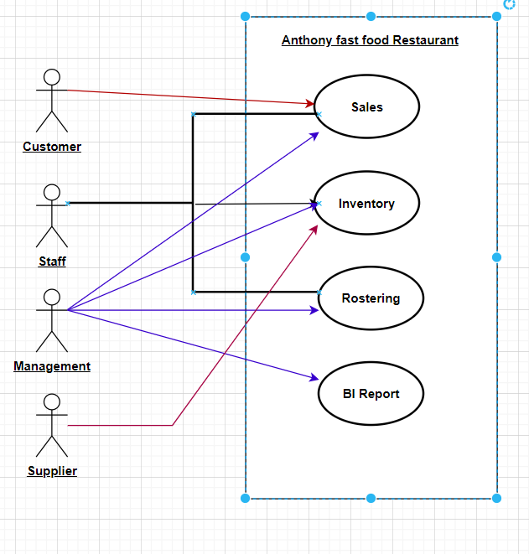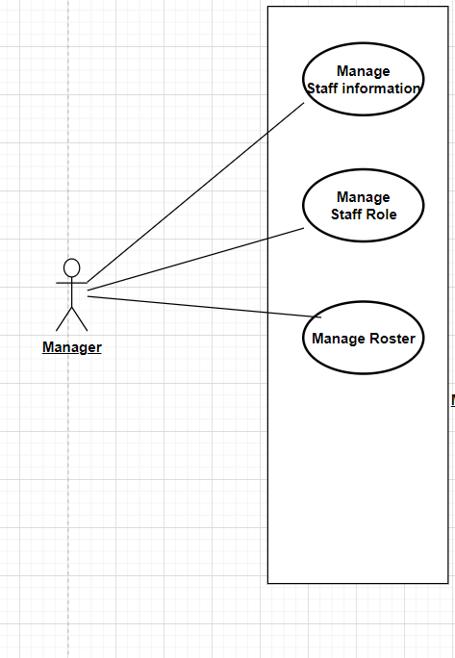

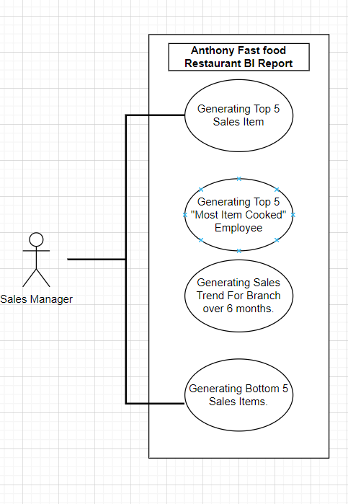

## Out of Scope

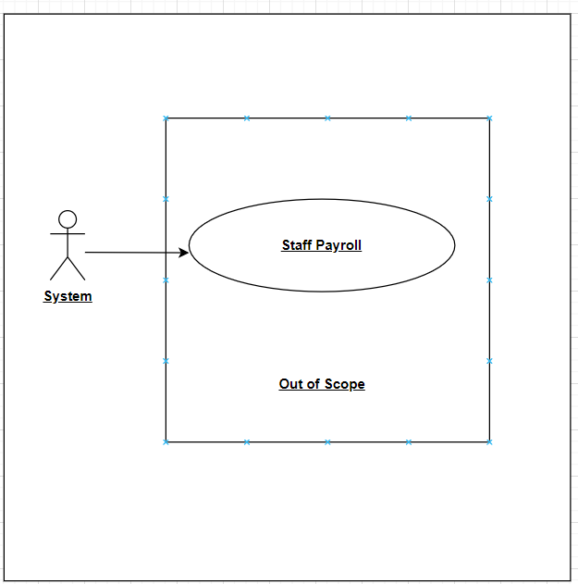

## Functional Decomposition

1. Manage Menu Item   
   (User Story: As a Manager, I need to be able to manage (CRUD) Menu Items so that I can ensure that the menu is correct and accurate.)  
   (need to remember ingredients of a menu item)
   1. Create Menu Item
   2. Read Menu Item
   3. Update Menu Item
   4. Remove Menu Item
2. Manage Menu Category
   1. Create Menu category
   2. Update Menu category
   3. Read Menu category
   4. Remove Menu category
3. Manage Customer Information
   1. Create Customer Profile
   2. Read Customer Profile
   3. Update Customer Profile
   4. Delete Customer Profile
4. Manage Order
   1. Place order (include payments) (include updating qoh of inventory item)
   2. Indicate cooking item
   3. Cook item
   4. Indicate item cooked
   5. Indicate collected
5. Manage Inventory Item
   1. Create Inventory
   2. Update Inventory
   3. Read Inventory
   4. Delete Inventory
6. Manage Supplier Information
   1. Create Supplier Profile
   2. Read Supplier Profile
   3. Update Supplier Profile
   4. Delete Supplier Profile
7. Manage Inventory Stock
   1. Generate P.O. (Purchase order) (QoH <= reOrderLevel)
   2. Create P.O.
   3. Read P.O.
   4. Adjust P.O.
   5. Delete P.O.
   6. Send P.O. to supplier
   7. Receive Invoice
      1. Import Invoice
      2. Check Invoice vs P.O.
      3. Check Invoice vs Actual goods
      4. Update Status (ready for payment) & Update stock QoH
   8. Generate Invoice Payment

1. Manage Staff Information
   1. Create staff profile (10 new staff per year)
   2. Read Staff profile
   3. Update Staff profile (20 staff changes per year)
   4. Delete Staff Profile (5 staff leave per year)
2. Manage Staff Role
   1. Create staff role
   2. Read Staff role
   3. Update Staff role
   4. Delete Staff role
3. Manage Roster
   1. Manage Empty Roster
      1. Create Empty Roster
      2. Read Empty Roster
      3. Update Empty Roster
      4. Delete Empty Roster
      5. Send SMS to staff
   2. Specify Availability (include CRUD & SMS to staff, this is an EBP)
   3. Assign Staff (include CRUD & SMS to staff, this is an EBP)
   4. Check-in
   5. Check-out

1. Generate B.I. Report
   1. Generate Top 5 Sale Item.
   2. Generate Top 5 “Most items cooked” Employee.
   3. Generate sales trend for branch over 6 months.
   4. Generate Bottom 5 Sale Item.

List the system/organizational interfaces that are **out of scope**. Mention the name and a brief 2-3 lines short description for each interface that is out of scope.

# Functional Requirements

This section describes the *Functional requirements* part of the Business Requirements. In Use case approach, the *Functional Requirements* comprises of Actor Profile Specification, Essential Use case diagram and Essential Use case specification in narrative text form.

*All requirements are specified to a level of detail sufficient to enable developers to specify and build the software application. Every stated requirement should be understandable by users, developers, operators and external system staff.*

## Actor Profiles Specification

This section describes all the Actors and their profiles within the context of the Business Requirements being documented. An Actor is a person, organization or an external system/sub-system/program that has interactions with the Application. Actors, by definition, are external to the system with which they are having interactions. Actors have goals that are achieved by use cases. Typically, Actors have behaviour and are represented by the roles they play in the use cases. An Actor stimulates the system by providing input and/or receiving something of measurable value from the system.

Provide the Actor profile information using the following table.

|  |  |  |  |
| --- | --- | --- | --- |
| **Actor Name** | Actor Type | Access Type needed | Comments |
| **Manager** | Primary Actor | Create  Print  Read  Export  Update  Others  Delete | Manager hs all the rights to create a profile |
| **Staff** | Supporting Actor | Update  Read | Staff can only read or update. |
| **Customer** | Supporting Actor | Read  Update | Customer only read or update. |

Please include here the Essential Use Case Diagram for the functional Requirements.

3.2 Essential Use Case Specifications

|  |  |  |
| --- | --- | --- |
| **Use Case ID** | **Follow numbering from Functional Hierarchy Diagram** | |
| **Use Case Name** | Create Staff Profile | |
| **Scenario** |  | |
| **Trigger Event** | Staff wish to register on company’s portal with their Name, Address, Dob and Email. | |
| **Actors** | Staff | |
| **Related Use Cases** | 1.1.1 | |
| **Stakeholders** | Interested parties: staff, management | |
| **Preconditions** | the system allows modify staff information such as name, address, dob and email. | |
| **Post conditions** | Staff detail have been updated. | |
| **Flow of Events** | **Actor** | **System** |
|  | *Add Staff detail.* | *Staff details form.* |
|  | *Name, Email, Mobile Number, Address* | Validate data inputs according to data type and length. |
|  | *submits detail* | *You have successful register.* |
|  | *Email conformation* | *“New staff profile created”* |
| **Extensions (or Alternatives)** | *- At any time, System fails,*  *- actor restarts system*  *- logs in*  *- requests recovery from prior state* | |
| *Invalid staff details. Please refresh and re-enter the information.*  *Staff details are already present in the system; staff members should log in using their ID.*  *Failed staff email confirmation/acknowledgment.*  *Kindly resend the email.* | |
| **Open Issues (or special requirements)** |  | |
| **Frequency** | *Ad hoc* | |

|  |  |  |
| --- | --- | --- |
| **Use Case ID** | **Follow numbering from Functional Hierarchy Diagram** | |
| **Use Case Name** | Read Staff profile | |
| **Scenario** |  | |
| **Trigger Event** | Staff wish to check their profile. | |
| **Actors** | Staff | |
| **Related Use Cases** | 1.1.2 | |
| **Stakeholders** | Interested parties:  Roster officer, staff, management | |
| **Preconditions** | The information of the staff member should be pre-updated in the system, and a corresponding staff ID should be generated | |
| **Post conditions** | The team member should now have the capability to access and review their own profile. | |
| **Flow of Events** | **Actor** | **System** |
|  | *Review staff details* | * *Request entry of employee ID* |
|  | *Staff ID entered* | * Confirms the entered staff ID. |
|  |  | * *If the staff ID is not verified, prompt for re-entry.* * *Staff ID successfully verified.* * *Display staff profile details.* |
| **Extensions (or Alternatives)** | * + *If the system encounters a failure:* * *The actor initiates a system restart.* * *The actor logs in again.* * *The actor requests recovery from the previous state.* | |
| * *If the staff ID is not accepted, reload and re-enter.* * *If the staff ID is not already in the system, re-enter the ID.* * *If staff ID confirmation/acknowledgment fails, re-enter the ID.* | |
| **Open Issues (or special requirements)** |  | |
| **Frequency** | *Ad hoc* | |

|  |  |  |
| --- | --- | --- |
| **Use Case ID** | **Follow numbering from Functional Hierarchy Diagram** | |
| **Use Case Name** | Update Staff Profile | |
| **Scenario** |  | |
| **Trigger Event** | Staff Update their profile | |
| **Actors** | Staff | |
| **Related Use Cases** | 1.1.3 | |
| **Stakeholders** | Interested parties:  Staff, management | |
| **Preconditions** | The system should have been updated with the staff member's details, and a staff ID should have been generated. | |
| **Post conditions** | The staff member is now able to access and view their profile. | |
| **Flow of Events** | **Actor** | **System** |
|  | *Review Staff details* | *Request entry of “staff ID”.* |
|  | *Staff ID Enter* | Validate the entered “staff ID”. |
|  |  | * *If staff ID is not verified, prompt for re-entry.* * *Confirm staff ID verification.* * *Display staff profile details upon successful verification.* |
|  | * Revise staff information such as name, address, date of birth, mobile number, and/or email. * Click on "Update Details." | * *Staff information successfully modified in the staff profile.* |
| **Extensions (or Alternatives)** | *In the event of a system failure:*   * *The actor initiates a system restart.* * *Subsequently, they log in to the system.* * *A request for recovery from the previous state is made* | |
| * If the staff ID is not accepted: * The instruction is to reload and re-enter the staff ID. * If the staff ID is not already present in the system: * The directive is to confirm/acknowledge the staff ID again, and if unsuccessful, to re-enter the ID. * If there is a failure in staff ID confirmation/acknowledgment: * The procedure is to re-enter the staff ID. * Issues related to staff profile details not updating are noted, and it is advised to contact the HR department for resolution.. | |
| **Open Issues (or special requirements)** |  | |
| **Frequency** | *Ad hoc* | |

|  |  |  |
| --- | --- | --- |
| **Use Case ID** | **Follow numbering from Functional Hierarchy Diagram** | |
| **Use Case Name** | Delete Staff Profile | |
| **Scenario** |  | |
| **Trigger Event** | Staff wish to delete profile – Not interested anymore. | |
| **Actors** | Staff | |
| **Related Use Cases** | 1.1.4 | |
| **Stakeholders** | Interested parties:  HR Staff, management | |
| **Preconditions** | The information about the staff member should already exist within the system, and the staff ID should have been generated. | |
| **Post conditions** | The team member should now have the capability to remove their profile from the system | |
| **Flow of Events** | **Actor** | **System** |
|  | *Display staff information* | *Request entry of staff ID* |
|  | *Enter staff ID* | * Validate entered staff ID. * If staff ID is not verified, prompt for re-entry. * Confirm staff ID verification. * Display staff profile details. |
|  | *Authorized Staff presses the "Delete" button to confirm the deletion* | *Display message: "Roster deleted successfully."* |
| **Extensions (or Alternatives)** | *In case of login input error (username or password), display an error message and prompt the Authorized Staff to re-enter their credentials.* | |
| n case of any issue loading or retrieving the "Delete Roster" screen, display an error message instructing the Authorized Staff to contact the IT team. | |
| **Open Issues (or special requirements)** | *Authorized Staff must have valid login details (username and password). An existing roster must be available for deletion.* | |
| **Frequency** | *Ad hoc* | |

|  |  |  |
| --- | --- | --- |
| **Use Case ID** | **Follow numbering from Functional Hierarchy Diagram** | |
| **Use Case Name** | Create Staff Role | |
| **Scenario** | Manager creates staff role within system. | |
| **Trigger Event** | Manager | |
| **Actors** | Manager | |
| **Related Use Cases** | 1.2.1 | |
| **Stakeholders** | Interested parties:  Manager , Staff | |
| **Preconditions** | The management ought to acknowledge the necessity for incorporating a new staff position within the system | |
| **Post conditions** | Staff Role successfully created | |
| **Flow of Events** | **Actor** | **System** |
|  | *Management initiates the staff role creation process.* | *A prompt requests the entry of the Management ID..* |
|  | *Management ID is entered.* | * The system verifies the entered Management ID. * If Management ID is not verified, a request to re-enter is prompted. * Once the Management ID is verified, the Create Staff Role form is displayed. |
|  | * Management provides details such as Staff Role Name, Description, Experience, and Skills. | * *An acknowledgment confirms the initiation of the new staff role creation.* |
|  | * The creation of the new staff role is confirmed. | * *The system displays a success message: "New Role Created."* |
| **Extensions (or Alternatives)** | *If the system experiences a failure at any point, the standard procedure involves the following steps:*   * *The actor initiates a system restart.* * *Subsequently, the actor logs in.* * *Finally, the actor requests recovery from the system's prior state.* | |
| * *Unable to accept Management ID. Please reload and re-enter.* * *The provided Management ID is not currently registered in the system.* * *Confirmation/acknowledgment for the Management ID failed. Please re-enter the ID.* * *The management is not authorized to create a new role.* * *The new role being created already exists in the system.* | |
| **Open Issues (or special requirements)** | *Staff must have valid login details, username and password* | |
| **Frequency** | *Ad hoc* | |

|  |  |  |
| --- | --- | --- |
| **Use Case ID** | **Follow numbering from Functional Hierarchy Diagram** | |
| **Use Case Name** | Read Staff role Details | |
| **Scenario** |  | |
| **Trigger Event** | Managers wish to view staff role | |
| **Actors** | Management | |
| **Related Use Cases** | 1.2.2 | |
| **Stakeholders** | Interested parties:  HR Staff, management, system | |
| **Preconditions** | The management ought to acknowledge the necessity of gaining insight into the staff's role within the system. | |
| **Post conditions** | The management should be able to access, display, and view the desired staff role successfully. | |
| **Flow of Events** | **Actor** | **System** |
|  | *Click on "View Staff Role" in the management interface.* | *Enter the Management ID when prompted.* |
|  | *Verify the entered Management ID.* | * If the Management ID is not verified, please re-enter it. * Once the Management ID is verified, click on "Enter Role ID." |
|  | * Enter the Staff Role ID. | * *The Management should enter the Staff Role ID.* |
|  | * Verify the Role ID entered. | * *Display the details of the Staff Role.* |
|  |  | * *Management reviews the details of the Staff Role.* |
| **Extensions (or Alternatives)** | *If the system fails at any point:*   * *The actor initiates a system restart.* * *The actor logs in.* * *The actor requests recovery from the prior state.* | |
| * *Role not accepted. Please reload the page and re-enter the information.* * *Role ID is not currently registered in the system.* * *Confirmation/acknowledgment for Management ID failed. Please re-enter the ID.* * *The staff role being accessed does not exist in the system.* | |
| **Open Issues (or special requirements)** | *HR Staff must have valid login details, including username and password.* | |
| **Frequency** | *Ad hoc* | |

|  |  |  |
| --- | --- | --- |
| **Use Case ID** | **Follow numbering from Functional Hierarchy Diagram** | |
| **Use Case Name** | Update Staff Role | |
| **Scenario** |  | |
| **Trigger Event** | update Staff Role by Manager | |
| **Actors** | Manager | |
| **Related Use Cases** | 1.2.3 | |
| **Stakeholders** | Interested parties:  Manager, HR System | |
| **Preconditions** | The management ought to acknowledge the necessity for a thorough review and update of staff role details within the system. | |
| **Post conditions** | Existing Staff Role must be viewed, Update. | |
| **Flow of Events** | **Actor** | **System** |
|  | * *Management clicks to update staff role.* | * *Prompt appears to enter Management ID.* |
|  | * *Management ID is entered.* | * System verifies the entered Management ID. * If Management ID is not verified, prompt to re-enter. * Once Management ID is verified, proceed with the update. |
|  | * *Click 'Enter Role ID'* | * proceed to input the Staff Role ID. |
|  | * *Management inputs Staff Role ID* | * Verification of Role ID   Display of Staff Role details |
|  | * *Management edits Staff Role Name, Description, Experience, and Skills*   *Click on "Update Details"* | * Confirmation of Staff Role Details Update * Confirmation prompt to update details. * Displayed message: "Staff Role Details Updated" |
| **Extensions (or Alternatives)** | *Whenever the system experiences a failure:*   * *The actor initiates a system restart.* * *Subsequently, the actor logs in.* * *The actor then requests recovery from the system's prior state.* | |
| * *Role not accepted. Please reload and re-enter.* * *Role ID is not currently in the system.* * *Management ID confirmation/acknowledgment failed. Please re-enter the ID.* * *The staff role being accessed does not exist in the system.* * *Staff role details are not being updated. Please contact the technical team.* | |
| **Open Issues (or special requirements)** |  | |
| **Frequency** | *Ad hoc* | |

|  |  |  |
| --- | --- | --- |
|  | **Follow numbering from Functional Hierarchy Diagram** | |
| **Use Case Name** | Delete Staff Role | |
| **Scenario** |  | |
| **Trigger Event** | Delete Staff Role by Manager | |
| **Actors** | Manager officer | |
| **Related Use Cases** | 1.3.3 | |
| **Stakeholders** | Interested parties:  Manager, HR System | |
| **Preconditions** | The management ought to acknowledge the necessity of removing staff role details from the system. | |
| **Post conditions** | The desired staff role should be efficiently accessed, displayed, and deleted by the management. | |
| **Flow of Events** | **Actor** | **System** |
|  | * *Click on "View Staff Role" in the management interface.* | * *Prompt to enter the Management ID.* |
|  | * *Enter the Management ID.* | * Verify the entered Management ID. * If the Management ID is not verified, re-enter it. * Once the Management ID is verified |
|  | * *Click on "Enter Role ID" in the interface.* | * Enter the Staff Role ID. |
|  | * *Management accesses Staff Role ID.* | * *Verification of Role ID*   *Staff Role details are presented* |
|  | * *Confirmation of Staff Role Deletion* | * Verification prompt for staff role deletion * System message confirms   “Successful Deletion of Staff Role” |
| **Extensions (or Alternatives)** | *Whenever the system encounters a failure:*   * *The actor initiates a system restart.* * *Logs in to the system.* * *Initiates a recovery request to restore to the previous state.* | |
| * Role not accepted. Please reload the page and re-enter the role. * Role ID is not present in the system. * Management ID confirmation/acknowledgement failed. Please re-enter the ID. * The staff role being accessed does not exist in the system. * Staff role details are not being deleted. Kindly contact the technical team for assistance. | |
| **Open Issues (or special requirements)** |  | |
| **Frequency** | *Ad hoc* | |

|  |  |  |
| --- | --- | --- |
|  | Follow numbering from Functional Hierarchy Diagram | |
| **Use Case Name** | Create Empty Roster | |
| **Scenario** |  | |
| **Trigger Event** | The management intends to generate a blank roster. | |
| **Actors** | Management | |
| **Related Use Cases** | 1.3.2 | |
| **Stakeholders** | Interested parties:  Manager, staff | |
| **Preconditions** | The management must acknowledge the necessity of generating an empty roster in the system. | |
| **Post conditions** | Upon completion, the management should have successfully created an empty roster within the system. | |
| **Flow of Events** | **Actor** | **System** |
|  | * Management initiates the staff roster creation process. | * *A prompt appears to enter the Management ID.* |
|  | * The Management ID is inputted. | * The system verifies the entered Management ID. |
|  |  | Management ID not Verified, Re-Enter, |
|  |  | Management ID verified. |
|  |  | Create Roster from displayed. |
|  | Management enters Roster_id,Date,StartTime,EndTime,[Role_id,Qty_staff] Click create roster | Acknowledgement to create a roster. |
|  | Create a new staff roster confirmed | New roster created successfully.  Message” New roster Created” |
| **Extensions (or Alternatives)** | *In case of any issues during the creation of an empty roster: Display an error message, and contact the IT team.* | |
| If there are issues storing the template in the Roster database, display an error message and inform the IT team. | |
| **Open Issues (or special requirements)** |  | |
| **Frequency** | *Ad hoc* | |
| **Use Case ID** | **Follow numbering from Functional Hierarchy Diagram** | |
| **Use Case Name** | Read Empty Roster | |
| **Scenario** |  | |
| **Trigger Event** | The management desires to access and review the roster pertaining to a specific date to Date. | |
| **Actors** | Roster officer | |
| **Related Use Cases** | 1.3.2 | |
| **Stakeholders** | Interested parties:  Roster officer, staff | |
| **Preconditions** | Roster table exists | |
| **Post conditions** | Empty roster is retrieved successfully | |
| **Flow of Events** | **Actor** | **System** |
|  | *Access the staff roster by clicking on the "View Staff Roster" option.* | *Input roster ID* |
|  | Verify the entered management ID.  Management ID entered. | * Check if the roster exists |
|  | *Enter Roster ID.* |  |
|  | *Management inputs the date.*  Clicks "View Roster" and receives. | Validate the input roster ID |
|  | *Proceeds to view the staff roster for the specified date.* | Read empty roster from the roster table with the given roster ID |
| **Extensions (or Alternatives)** | *Whenever the system encounters a failure:*   * *The actor initiates a system restart.* * *Logs in to the system.* * *Requests recovery from the prior state.* | |
|  | * *Management ID not recognized. Please reload and re-enter.* * *Management ID is not currently in the system.* * *Failed confirmation/acknowledgment for Management ID. Please re-enter the ID.* | |
| **Open Issues (or special requirements)** | *None* | |
| **Frequency** | *Ad hoc* | |

|  |  |  |
| --- | --- | --- |
| **Use Case ID** | **Follow numbering from Functional Hierarchy Diagram** | |
| **Use Case Name** | Specify Availability | |
| **Scenario** |  | |
| **Trigger Event** | Specify Staff Availability - Roster ID, Staff ID | |
| **Actors** | Roster Officer | |
| **Related Use Cases** | 1.3.3 | |
| **Stakeholders** | Interested parties:  Roster Officer, Staff | |
| **Preconditions** | There needs to be a provision for staff availability. | |
| **Post conditions** | The successful creation of staff availability has been accomplished. | |
| **Flow of Events** | **Actor** | **System** |
|  | *Staff should indicate their availability.* | *Prompt to enter “Staff ID”.* |
|  | *Input Staff ID when prompted.* | * The system validates the entered Staff ID. * If the Staff ID is not verified, please re-enter. |
|  | Enter “Roster_ID”  Staff inputs the Roster_ID. | *The system verifies the “Roster_ID”.*  *the corresponding roster is presented for availability creation.* |
|  | Staff members proceed to create their availability within the roster.  By clicking on "Create Availability" and confirming when prompted. | *A confirmation prompt appears and upon confirmation.*  *the staff's availability is successfully added to the roster.*  *the staff's availability is successfully added to the roster.*  *A message confirms the creation with the display: "New Availability Created."* |
| **Extensions (or Alternatives)** | *Whenever there is a system failure:*  *The actor initiates a system restart.*  *Subsequently, they log in.*  *A recovery from the prior state is then requested.* | |
| * *Staff ID not recognized. Please reload and re-enter.* * *Staff ID is not currently registered in the system.* * *Confirmation/acknowledgment of Staff ID failed. Please re-enter the ID.* * *Staff is not authorized to modify roster availability.* * Roster ID not accepted by the system. * Roster ID accepted but the roster details do not display properly. * Staff cannot specify availability in the roster displayed. Contact management. | |
| **Open Issues (or special requirements)** |  | |
| **Frequency** | *Ad hoc* | |

|  |  |  |
| --- | --- | --- |
| **Use Case ID** | **Follow numbering from Functional Hierarchy Diagram** | |
| **Use Case Name** | Assign Staff | |
| **Scenario** |  | |
| **Trigger Event** | Management desires to review the staff's availability through their respective Staff ID. | |
| **Actors** | Manager | |
| **Related Use Cases** | 1.3.4 | |
| **Stakeholders** | Interested parties:  Management | |
| **Preconditions** | Roster table, Staff table, RosterAllocation table exists. | |
| **Post conditions** | Staff is allocated to the roster successfully | |
| **Flow of Events** | **Actor** | **System** |
|  | *Management selects "View Staff Roster."* | *Input RosterID, StaffID* |
|  | *The management ID is inputted.* | * Check if the roster exists * Check if the staff exists |
|  | *Enter “Staff_ID”.*  The management inputs the Staff ID.  Click on "View Staff Availability."  The management reviews the staff availability. | *Validate the inputs*  *Update the RosterAllocation table to allocate the staff to the roster* |
| **Extensions (or Alternatives)** | *Whenever there is a system failure:*   * *The actor initiates a system restart.* * *Subsequently logs in to the system.* * *Requests recovery from the previous state.* | |
| * *Please reload and re-enter your Management ID as it was not accepted.* * *The Management ID is not yet in the system.* * *There was an issue confirming/acknowledging your Management ID. Please re-enter the ID.* * *The system did not accept the Staff ID. Please try again.* * *The Staff ID is accepted, but the staff availability has not been updated in the system.* | |
| **Open Issues (or special requirements)** |  | |
| **Frequency** | *Ad hoc* | |

|  |  |  |
| --- | --- | --- |
| **Use Case ID** | **Follow numbering from Functional Hierarchy Diagram** | |
| **Use Case Name** | Send SMS | |
| **Scenario** |  | |
| **Trigger Event** | The management wants to send a text message to the staff, including their staff_ID. | |
| **Actors** | Management | |
| **Related Use Cases** | 1.3.5 | |
| **Stakeholders** | Interested parties:  Manager, Staff | |
| **Preconditions** | The management wants to send a text message to the staff, including their staff ID. | |
| **Post conditions** | That staff member needs to confirm the text message. | |
| **Flow of Events** | **Actor** | **System** |
|  | *Management sends an SMS* | *Enter the management ID when prompted.* |
|  | *Confirm the entered management ID.* | * The system verifies the entered Management ID. * If the Management ID is not verified, the system prompts for re-entry. * Once the Management ID is verified, the process is completed. |
|  | *Enter Staff_ID.*  The management inputs the Staff_ID.  Send SMS | *The Staff_ID is checked and verified.*  *Confirmation through SMS is needed.*  *Confirmation via SMS received.* |
| **Extensions (or Alternatives)** | *Whenever there is a system failure:*  *• The actor initiates a system restart.*  *• Subsequently logs in to the system.*  *• Requests recovery from the previous state.*   * *Management ID not recognized. Please reload and enter the ID again.* * *Management ID is not yet registered in the system.* * *Confirmation/acknowledgment for Management ID failed. Please re-enter the ID.* * *Management is not authorized to create a new roster.* * *Staff ID is not accepted by the system.* * *Staff ID is accepted, but the staff phone number is not in the system.* * *SMS delivery is unsuccessful.* * *Confirmation SMS from the staff is not received.* | |
| **Open Issues (or special requirements)** | *SMS sending platform* | |
| **Frequency** | *Ad hoc* | |

|  |  |  |
| --- | --- | --- |
| **Use Case ID** | **Follow numbering from Functional Hierarchy Diagram** | |
| **Use Case Name** | Create Check in | |
| **Scenario** |  | |
| **Trigger Event** | Check in Time – Staffed time | |
| **Actors** | Staff | |
| **Related Use Cases** | 1.3.6 | |
| **Stakeholders** | Interested parties:  Management, Staff | |
| **Preconditions** | The staff is registered in the system.  The staff is assigned to the shift for the day. | |
| **Post conditions** | Staff check-in is automatically recorded in the system with the accurate time. | |
| **Flow of Events** | **Actor** | **System** |
|  | *Staff clicks Create Check In* | *Automatically detects the staff's presence via ID card scan or biometric verification.* |
|  | Staff approaches the check-in terminal.  Staff_ID entered. | Retrieves the current time as the check-in time  Verifies Staff ID and assigns the retrieved time as their check-in time. |
|  | Staff clicks check-in. | *Performs a CREATE operation on the database to log the check-in record* |
|  | Check-in is successfully created. | *Displays a confirmation message: "Check-in successful at [time]."* |
| **Extensions (or Alternatives)** | *If the system cannot detect or verify the staff's ID:*   * *Prompt the staff to try scanning their ID again.* * *If the issue persists, direct the staff to seek assistance.*   *System failure scenarios:*   * *Automatically attempt to restart and recover the last known state.* * *Log the incident for technical support.* | |
| **Open Issues (or special requirements)** | *Ensure time synchronization across all check-in terminals to prevent discrepancies.* | |
| **Frequency** | *Ad hoc* | |

|  |  |  |
| --- | --- | --- |
| **Use Case ID** | **Follow numbering from Functional Hierarchy Diagram** | |
| **Use Case Name** | Create Check Out | |
| **Scenario** |  | |
| **Trigger Event** | Staff Check Out- Staffed Time | |
| **Actors** | Staff, system | |
| **Related Use Cases** | 1.3.6 | |
| **Stakeholders** | Interested parties:  Management, Staff | |
| **Preconditions** | The staff is registered and was logged in into the system for their shift on the day. | |
| **Post conditions** | Staff check-out time is automatically recorded in the system with the accurate time. | |
| **Flow of Events** | **Actor** | **System** |
|  | *Staff clicks on "Create Check Out."* | *Automatically detects the staff's presence via ID card scan or biometric verification* |
|  | Staff approaches the check-out terminal.  Staff enters Staffed Time | Retrieves the current time as the check-out time.  Verifies Staff ID and assigns the retrieved time as their check-out time |
|  | Staff clicks to create a check-Out. | *Performs a CREATE or UPDATE operation on the database to log the check-out record.* |
|  | Check out created | *The check-out is successfully created.*  *Displays a confirmation message: "Check-out successful at [time]."* |
| **Extensions (or Alternatives)** | *If the system cannot detect or verify the staff's ID:*   * *Prompt the staff to try scanning their ID again.* * *If the issue persists, direct the staff to seek assistance.*   *System failure scenarios:*   * *Automatically attempt to restart and recover the last known state.* * *Log the incident for technical support.* | |
| **Open Issues (or special requirements)** | *Integration with time management software for real-time attendance tracking.* | |
| **Frequency** | *Ad hoc* | |

|  |  |  |
| --- | --- | --- |
| **Use Case ID** | **Follow numbering from Functional Hierarchy Diagram** | |
| **Use Case Name** | Sold | |
| **Scenario** |  | |
| **Trigger Event** | Generate Top 5 Sale Item – SaleID, ItemID | |
| **Actors** | Sales Staff / Management | |
| **Related Use Cases** | 1.3.7 | |
| **Stakeholders** | Interested parties:  Management, Staff | |
| **Preconditions** | The system has a sales report/chart. | |
| **Post conditions** | Top 5 sales Item displayed | |
| **Flow of Events** | **Actor** | **System** |
|  | *Open the sales report.* | *It will ask you to input the Management ID.* |
|  | Enter the Management ID. | The system checks if the Management ID is correct.  If the Management ID is not verified, please re-enter.  Once the Management ID is verified.  Now, it will ask you to input the Sales ID. |
|  | Enter the Sales ID. | *The system verifies the Sales ID.*  *prompted to input the Item ID.* |
|  | Enter the Item ID. | *The system verifies the Item ID.* |
|  | Click on "Generate Top 5 Sale Items." | *A message will appear displaying "The Top 5 items."* |
| **Extensions (or Alternatives)** | *In case the system encounters a failure:*   * *Restart the system.* * *Log in again.* * *Request recovery from the previous state.* * *Sales ID not recognized. Please reload and enter it again.* * *Item ID not accepted. Please re-enter.* * *The sales data could not be saved in the system.* | |
| **Open Issues (or special requirements)** |  | |
| **Frequency** | *Ad hoc* | |

|  |  |  |
| --- | --- | --- |
| **Use Case ID** | **Follow numbering from Functional Hierarchy Diagram** | |
| **Use Case Name** | Cooked | |
| **Scenario** |  | |
| **Trigger Event** | Generate Top 5 “Most Items Cooked” Employee – Staff ID, Item ID | |
| **Actors** | Sales Staff / Management | |
| **Related Use Cases** | 1.3.8 | |
| **Stakeholders** | Interested parties:  Management, Staff | |
| **Preconditions** | We need information about what food items were prepared and by whom. | |
| **Post conditions** | The top 5 staff members who cooked the most items are ready for review and analysis. | |
| **Flow of Events** | **Actor** | **System** |
|  | *Click on the "Items Cooked Report" option* | *You'll be asked to input your Management ID.* |
|  | Enter your Management ID as prompted. | The system will check the entered Management ID.  If the Management ID is not verified, please re-enter it.  Once your Management ID is verified, proceed.  Prompted to enter your Staff ID. |
|  | Enter your Staff ID accordingly | *The system will verify your Staff ID.*  *Prompted to enter the Item ID.* |
|  | Enter the Item ID as required. | *system will verify the entered Item ID.* |
|  | Click on "Generate Top 5 Employees with the Most Items Cooked." | *A list will appear displaying "The Top 5 Employees with the Most Items Cooked."* |
| **Extensions (or Alternatives)** | *In case the system encounters a failure:*   * *Restart the system.* * *Log in again.* * *Request recovery from the previous state.* * *Try reloading and entering the Staff_ID again as it was not accepted.* * *The Item ID was not accepted; please try entering it again.* * *The system did not save the data for who cooked which item.* | |
| **Open Issues (or special requirements)** |  | |
| **Frequency** | *Ad hoc* | |

|  |  |  |
| --- | --- | --- |
| **Use Case ID** | **Follow numbering from Functional Hierarchy Diagram** | |
| **Use Case Name** | Sales Pattern | |
| **Scenario** |  | |
| **Trigger Event** | Create a report showing the sales trend for the branch over the past 6 months. | |
| **Actors** | Sales Staff / Management | |
| **Related Use Cases** | 1.3.9 | |
| **Stakeholders** | Interested parties:  Management, Staff , owner | |
| **Preconditions** | We need information about the dishes prepared and who made them. | |
| **Post conditions** | We've compiled a list of the top 5 employees who have cooked the most items, ready for review and analysis. | |
| **Flow of Events** | **Actor** | **System** |
|  | *Open the "Items Cooked Report."* | *It will ask you to input the Management ID.* |
|  | Enter the Management ID as prompted. | The system checks and confirms the entered Management ID.  If the Management ID isn't verified, please re-enter it.  Once the Management ID is confirmed, proceed.  You'll be prompted to input the Staff ID. |
|  | Enter the Staff ID as instructed. | *The system verifies the Staff_ID.*  *You'll then be asked to enter the Item ID.* |
|  | Enter the Item ID as required. | *system will verify the entered Item ID.* |
|  | Input the Item ID as required. | *The system checks and verifies the entered Item ID.* |
|  | Click on "Generate Top 5 Most Items Cooked Employees." | *A list will appear, displaying the "Top 5 Employees with the Most Items Cooked."* |
| **Extensions (or Alternatives)** | *In case the system encounters a failure:*   * *Restart the system.* * *Log in again.* * *Request recovery from the previous state.*   *Staff ID not recognized. Please reload the page and enter it again.*  *The information about who cooked which item was not saved in the system.* | |
| **Open Issues (or special requirements)** |  | |
| **Frequency** | *Ad hoc* | |

|  |  |  |
| --- | --- | --- |
| **Use Case ID** | **Follow numbering from Functional Hierarchy Diagram** | |
| **Use Case Name** | Newly sold | |
| **Scenario** |  | |
| **Trigger Event** | Create a list of the five least-selling items, including SaleID and ItemID | |
| **Actors** | Sales Staff / Management | |
| **Related Use Cases** | 1.3.10 | |
| **Stakeholders** | Interested parties:  Management,owner | |
| **Preconditions** | The system has a sales report/chart. | |
| **Post conditions** | You can find the 5 items with the lowest sales from the list. | |
| **Flow of Events** | **Actor** | **System** |
|  | *Open the "Sales Report."* | *Prompt for enter Management ID* |
|  | Enter the Management ID. | The system checks and confirms the entered Management ID.  If the Management ID isn't verified, please re-enter it.  Once the Management ID is confirmed, proceed.  You'll be prompted to input the Sales ID. |
|  | Enter the Sales ID as instructed. | *The system verifies the Sales_ID.*  *You'll then be asked to enter the Item ID.* |
|  | Enter the sales_ID as required. | *system will verify the entered sales_ID.* |
|  | Input the ID as required. | *The system checks and verifies the entered sales_ID.* |
|  | Click on "Generate newly 5 sale items." | *A list will appear, displaying the "The Bottom 5 items"* |
| **Extensions (or Alternatives)** | *In case the system encounters a failure:*   * *Restart the system.* * *Log in again.* * *Request recovery from the previous state.*   *Sales ID not recognized. re-enter the Item ID as it was not accepted.*  *The sales data hasn't been saved in the system.* | |
| **Open Issues (or special requirements)** |  | |
| **Frequency** | *Ad hoc* | |

Attach the system sequence diagrams here. This shows the input and output events related to each use case.

Place your Operation Contracts here as they are part of the Unified Process Use-case model because they provide more analysis detail on the effect of the system operations implied in the use cases..

## Event table

|  |  |  |  |  |  |
| --- | --- | --- | --- | --- | --- |
| **Event** | **Trigger** | **Source** | **Use case** | **Response** | **Destination** |
| **Event** | Trigger | Source | Use case | Response | Destination |
| **Staff wish to register themselves on the business website** | Name, address, dob, mob, email | staff | Create Staff Profile | Msg: “You have successfully registered” | Staff |
| **Staff wishes to view their profile** | Staff_ID | mob | email | Staff | Read Staff profile  Display Staff profile detail | Staff profile details | Staff |
| **Staff wishes to view their profile** | Name, address, dob, mob, email | Staff | Update Staff profile | Updated | Staff |
| **Staff wishes to view their profile** | Staff_ID | staff | Delete Staff profile | Deleted | staff |
| **Management wishes to create a Staff Role within the system** | Name, description,  Experience,  Skills | management | Create Role | Msg: “new Role created” | management |
| **Management wishes to View Staff Role** | RoleID | management | Read Staff Role  Display Staff Role detail | Staff Role details | management |
| **View Staff Role** | RoleID | management | Update Staff Role  Delete Staff Role | Updated  Deleted | management |
| **Management wishes to create an Empty Roster** | Roster_id, Date, StartTime, EndTime , [Role_ID, Qty_staff] | management | Create Roster | Msg: “New roster created” | management |
| **Management wishes to View the Roster** | Date | management | Read Roster  Display Roster | Roster details | management |
| **Specify Staff Availability** | [Roster_ID],  Staff_ID, | Staff | Create Availability | Msg: “new Availability created” | Staff |
| **Management wishes to View the Availability** | Staff_ID | management | Read Availability  Display Availability | Availability details | management |
| **Send SMS** | Staff_ID | management | Send SMS | SMS acknowledgement  SMS confirmation | management |
| **Assign Staff to Rosters in Roster** | Roster_ID, [Staff_ID] | management | Create roster | Msg: “Staff Assigned” | management |
| **View Roster** | Roster_ID, [Staff_ID] | management | Read Roster  Display Roster | Roster details | management |
| **Send SMS** | Staff_ID | management | Send SMS | SMS acknowledgement  SMS confirmation | Staff |
| **Staff check-in** | Staff_ID, time | Staff | Create Checkin | Msg: ‘You are logged in | staff |
| **Staff check-out** | Staff_ID, time | Staff | Create Checkout | Msg: ‘You are logged ot | Staff |
| **Generate Top 5 Sale Item** | End of the Month |  | Produce prospective top 5 sales item | Prospective report | Sales |
| **Generate Top 5 “Most items cooked” Employee** | End of the Month |  | Produce prospective top 5 most cooked item | Prospective report | Sales |
| **Generate sales trends for branch over 6 months** | End of the Month |  | Produce prospective Sales trend in branch sales item | Prospective report | Sales |
| **Generate Bottom 5 Sale Item** | End of the Month |  | Produce prospective Bottom 5 sales item | Prospective report | Sales |

## User stories

|  |
| --- |
| As a roster manager, I want to create a weekly roster for employees by selecting employees from a list of available workers so that I can ensure adequate staffing levels.  Acceptance criteria:   * The platform must showcase a roster of accessible workers categorized by their availability and skills. * The platform should facilitate the roster manager in effortlessly relocating employees onto the roster through drag-and-drop functionality. * • The platform should produce a printable version of the roster. |
| * As the manager overseeing scheduling, my objective is to allocate shifts to employees listed on the roster to ensure they have clear knowledge of their designated work hours. * Acceptance criteria: * The system must exhibit the commencement and conclusion times for each shift. * The system should facilitate the roster manager in allocating employees to shifts. * The system should send notifications to employees regarding their allocated shifts. |
| As a scheduling supervisor, I aim to monitor employee presence to detect trends and manage any arising concerns.   * Acceptance criteria: * Employees should be able to record their start and end times for shifts. * The system should record employee attendance for each scheduled shift. * The system should produce reports detailing employee attendance. |
| As a As a roster manager, I want to manage employee leave requests so that I can ensure adequate staffing levels and maintain employee morale.  Acceptance criteria:   * The system should allow employees to submit leave requests online. * The system should allow the roster manager to approve or deny leave requests. * The system should send notifications to employees about the status of their leave requests. |
| As a roster manager, I aim to detect any possible clashes within the roster to proactively resolve them before they escalate.  Acceptance criteria:   * The system should recognize potential conflicts, including instances of overtime violations and scheduling overlaps. * The system should promptly notify the roster manager of any identified conflicts. * The system should offer recommendations for resolving potential conflicts. |

## Business Rules

This section lists and describes the business rules applicable to the proposed system.

Describe the business rules in the following tabular format. If the number of Business Rules is quite large, then you may also document Business rules in a separate document in the following tabular format and attach the rules document with this BRD.

|  |  |  |  |
| --- | --- | --- | --- |
| **Business Rule Id** | **Rule Name** | **Rule Description** | **Rule Source** |
| Shift | Maximum of 40 hrs per week | No staff should exceed the maximum of 40 hours per week | Fair work act |
| Staff | Minimum age | The staff appointed must be 16 an above year old. | Fair work act |

*Please refer to the following guidelines on business rule documentation :*

* *Document only Business rules here. Do not document workflow rules.*
* *There is no need to document rules (particularly structural rules) that are naturally expressed in the models and that are shown in the models.*
* *Document only semantic and explicit business rules or “unstructured” rules that do not appear in the models.*

# Data Requirements

This section describes the Data requirements part of the Business Requirements.

## Data Architecture

This section describes the Data Architectural requirements part of the Business Requirements.

### Domain Model

This section depicts the Data Architecture in the form of a Domain Model. The Domain model is used to model the conceptual classes, its attributes (fields), and the interrelationships (association, composition, aggregation and generalization) between the classes. Domain model is a representation of real world conceptual classes, not of software components.  
  
**Data Model.**  
**Roster**

rosterID (PK)

startDate

endDate

**Staff**

staffID (PK)

name

contactNumber

address

paymentDetails

**RosterAllocation**

rosterID (FK)

staffID (FK)

roleID (FK)

startTime

endTime

**Availability**

staffID (FK)

date

startTime

endTime

**Assignment**

rosterID (FK)

staffID (FK)

roleID (FK)

startTime

endTime

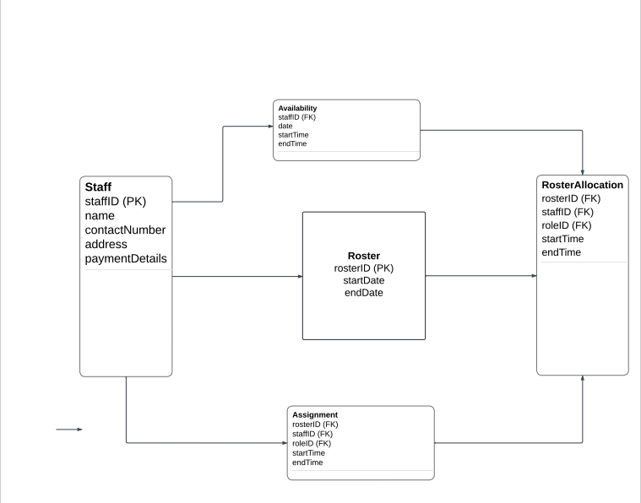

Please include here the Domain Model showing the following information :

* Class Name
* Attribute (field) Name
* Interrelationships between the classes (association, composition, aggregation and generalization)

### Entity Relationship Diagram

This section depicts the Data Architecture in the form of Entity Relationship Diagram (ERD).

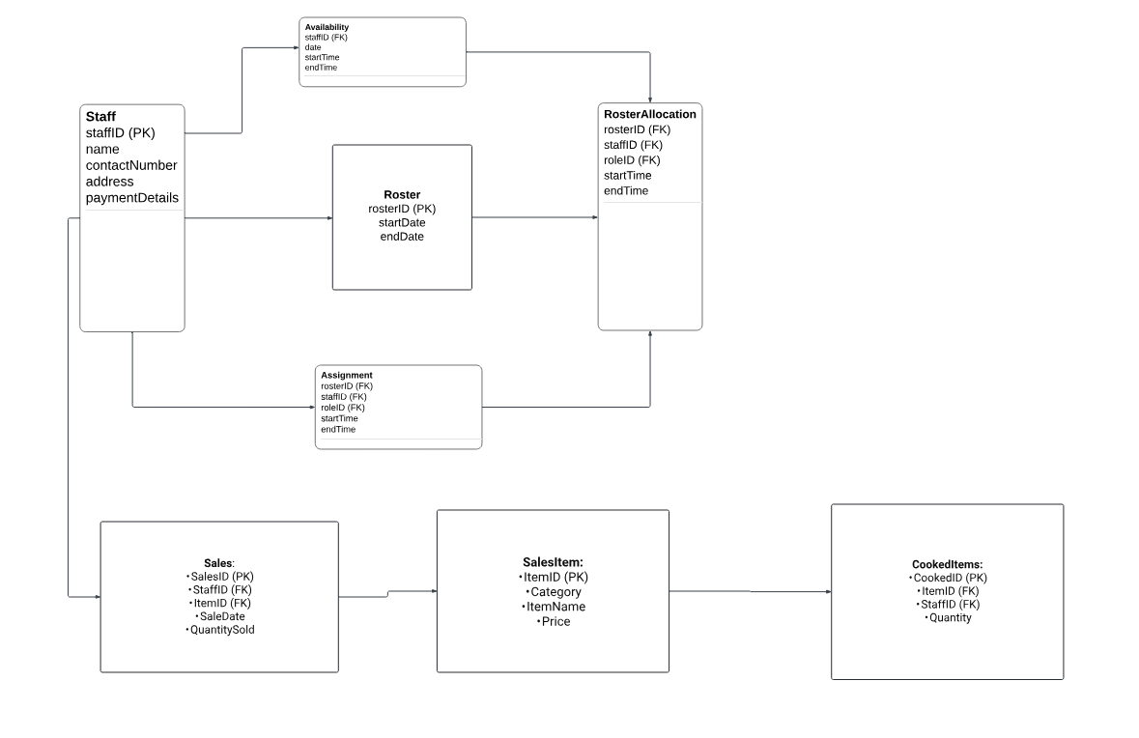

We want to represent our above Domain Model using Entity relationship diagram notation (crows feet notation, which is another popular form of representing our data architecture.

## Data Volumes

This section describes the expected approximate Data volumes (initial volume and annual growth %) for each conceptual Class or Entity.

|  |  |  |
| --- | --- | --- |
|  |  |  |
|  |  |  |
|  |  |  |
|  |  |  |

|  |  |  |
| --- | --- | --- |
| **Conceptual Class / Entity Name** | **Initial Volume (number of records)** | **Annual growth %** |
| *Roster* | *20* | *20%* |
| *Staff Profile* | *20* | *15%* |
| *Avaliability* | *15* | *20%* |
| *Role* | *5* | *15%* |
| *Assign Staff* | *10* | *20%* |
| *Check – In* | *10* | *15%* |
| *Check -Out* | *10* | *15%* |

If your UML tool provides facility to record data volumes information for each Conceptual Class, then record that information in the specific fields and ensure that those fields are included in the “Domain Class Definition Report” (refer section 4.6.1). If there is no such explicit facility to record the data volumes information, then please record the “Initial Volume” and “Annual Growth Rate (in %)” in the “Notes” field for each Conceptual Class and ensure that the “Notes” field is included in the “Domain Class Definition Report” (refer section 4.6.1).

*Please describe the following high-level Data Conversion issues in this section :*

* *Data that is required to be converted (list of conceptual entities in the source database)*
* *High-level mapping between source and target “to be converted” conceptual data structures*
* *Privacy and Freedom of Information and other compliance issues needed to be taken into consideration during data conversion*
* *Critical success factors*
* *Risks associated with the data conversion and contingency plans*
* *Data Conversion Acceptance criteria*

## Data Retention and Archiving

This section describes the Data retention (time frames for online Data retention before archiving) and also the archiving requirements.

* **Customer information must be preserved for a period of 2 years following the discharge of a customer.**
* **Employee records should be maintained for 5 years after an employee's termination.**
* **The retention and archiving guidelines may be stipulated by regulatory authorities (for instance, the ATO mandates retaining tax returns for 7 years).Please describe the time frames in number of years/months/days for online Data retention before the data is archived and purged.**

## Freedom of Information/Privacy Implications

This section describes the sensitivity levels of each class of data. The following criteria are used in determining the sensitivity level of each conceptual class/entity in line with the Government Core Policy Manual).

* ***Non-sensitive*** *information that would not reasonably be expected to cause injury (harm) if released to the public;*

* ***Protected A****: information that, if compromised, could reasonably be expected to cause injury (harm), e.g. loss of privacy;*
* ***Protected B****: information that, if compromised, could reasonably be expected to cause serious injury (harm), e.g. the conduct of a court proceeding would be adversely affected;*

* ***Protected C****: information that, if compromised, could reasonably be expected to cause extremely grave injury (harm), e.g. loss of life.*

Please describe the FOI/Privacy Implications for each conceptual Class or Entity in terms of the criteria described above. Please use the following table. Add more rows as necessary.

|  |  |
| --- | --- |
| **Conceptual Class / Entity Name** | **Data Sensitivity Level**  **(Non-sensitive,**  **Protected A,**  **Protected B,**  **Protected C)** |
| Roster | Non-sensitive |
| Staff Profile | Protected A |
| Availability | Protected A |
| Role | Protected A |
| Assign Staff | Protected A |
| Check – IN | Non-Sensitive |
| Check-Out | Non-Sensitive |

*Please generate and attach the Domain Class report. Most UML tools that support Class modeling will also provide facilities for generating the Class Definition report from the Domain Class Diagram. The Report should contain the following information :*

* *Class Name*
* *Brief Description of the Class*
* *Initial Data Volume of the Class (Approx.)*
* *Annual Data Growth Rate of the Class (in approx. %)*
* *Attributes (fields) of the Class : Attribute Name and brief description*

*Do this only if your tool allows you to generate this report. Otherwise, ignore this.*

# Non-Functional requirements

This section describes the non-functional requirements part of the Business Requirements. A non-functional requirement is typically a special requirement that is not easily or naturally specified in the text of the use case’s or function’s event flow. Examples of non-functional requirements include legal and regulatory requirements, application standards, and quality attributes of the system to be built including usability, reliability, performance or supportability requirements.

## Security Requirements

This section describes the Security requirements part of the Business Requirements.

### Authentication

This section describes the Authentication requirements part of the Business Requirements. Authentication is the process of verifying the genuineness of claims that a person/group makes to establish identity/eligibility for access to services. In order to ascertain the Authentication requirements of the Application, it is required to analyse the type of transactions that different Use cases/Business Functions trigger within the Application. The following criteria is used in determining transaction types of each use case/function (in line with Government Core Policy Manual) :

***Level 0 : Anonymous transaction*** *– triggers transactions that do not require or allow a person to be identified, or transactions which require protection of a person's identity. For example, access to online information about government programs or services or protecting a person's identity. Combining the transaction data with other data must not allow identification of a particular individual.*

***Level 1 : Pseudonymous transaction*** *– triggers transactions that do not require a person to be identified but do require a means for further contact to deliver a product or service. For example, a note from someperson@internet.ca can not be readily translated into an individual’s name, but it may be sufficient to request information, to provide some services, or on-going follow up.*

***Level 2 : Identified transaction*** *– triggers transactions that require that a person be specifically identified. The nature of the transaction may require confirmation of a person's identity (e.g., name, address, birth date, etc.) and/or data linking the person to a transaction (e.g., invoice number, personal health number, etc.).*

***Level 3 : Verified transaction*** *– triggers transactions that require: the person to be specifically identified; verification of the integrity of the data exchanged and the exchange itself; and, the creation of sufficient evidence to indicate that the person agreed to be bound by the transaction. For example, a note signed with a digital certificate, audit trails and security logs may provide sufficient evidence that a specific person intended to conduct a transaction.*

Please describe Authentication requirements for each Use Case or Business Function in terms of the criteria described above. Please use the following table. Add more rows as necessary.

|  |  |
| --- | --- |
| **Use Case / Business Function Name** | **Transaction type triggered**  **(Level 0 : Anonymous,**  **Level 1 : Pseudonymous,**  **Level 2 : Identified,**  **Level 3 : Verified)** |
| Create Staff Profile | Level 2: Identified |
| Update Staff role | Level 2: Identified |
| Create Empty Roster | Level 2: Identified |
| *Specify Availability* | Level 3: Verified |
| Assign Staff | Level 3: Verified |

### Authorization and Access Controls

This section describes the Authorization and Access Control requirements part of the Business Requirements. Authorization is the process of determining if the person/group, once identified through the “Authentication process”, is permitted to have access to certain services. The Authorization and Access Control requirements are best described through a matrix.

Please specify the Authorization and Access Control requirements between the various Actors/Business Units and the Domain Classes/Business Entities in the table below. Add more rows as necessary.

|  |  |  |
| --- | --- | --- |
| **Actor / Business Unit Name** | **Conceptual Class / Business Entity Name** | **Type of Access Control needed on the Conceptual Class / Business Entity :**  **C 🡪 Create**  **R 🡪 Read**  **U 🡪 Update**  **D 🡪 Delete** |
| Manager | Roster | C, R, U, D |
| Manager | Staff Profile | C, R, U |
| Staff | availability | R, U |
| Manager | Role | C, R, U, D |
| Manager | Assign Staff | C, R,U,D |
| Staff | Check – In | R,U |
| Staff | Check 0 Out | R, U |

## Availability Requirements

This section describes the system availability requirements.

Please specify the availability requirements for each Use Case or Business Function in the table below. Add more rows as necessary. If all use cases / business functions (the system as a whole) have the same uniform availability requirements, then describe this in the space below and delete the table below.

|  |  |
| --- | --- |
| **Use Case / Business Function Name** | **Availability Requirements**  **- Regular work hours**  **- 24x7**  **- Any other (please describe)** |
| Create staff profile | 24x7 |
| Read Staff profile | 24x7 |
| Update Staff profile | 24x7 |
| Delete Staff Profile | 24x7 |
| Create staff role | 24x7 |
| Read Staff role | 24x7 |
| Update Staff role | 24x7 |
| Delete Staff role | 24x7 |
| Manage Empty Roster | 24x7 |
| Create Empty Roster | 24x7 |
| Read Empty Roster | 24x7 |
| Update Empty Roster | 24x7 |
| Delete Empty Roster | 24x7 |
| Send SMS to staff | 24x7 |
| Specify Availability | 24x7 |
| Assign Staff | 24x7 |

## Usability Requirements

This section describes the system usability requirements. A usability requirement specifies how easy the system must be to use. Usability is a non-functional requirement, because in its essence it doesn't specify parts of the system functionality, but specifies only how that functionality is to be perceived by the user, for instance how easy it must be to learn and operate the system.

**• Learning Progression: A new user should achieve the ability to create a shift schedule within 2 days of training.**

**• Task Effectiveness: Users should be able to find and review product information within 10 seconds.**

**• Site Navigation: Users should access product information through no more than 3 web pages.**

**• Display Clarity: Text displayed on the Point-of-Sale screen should be easily visible from a distance of 1 meter.**

**• Audible Alerts: Significant signals and warnings should be communicated through sound.The customer will be able to see a large monitor display of the Point of Sale. Therefore, text should be easily visible from 1 meter. Avoid colors associated with common forms of colour blindness.  
  
The cashier is often looking at the customer or items, not the computer display. Therefore, signals and warnings should be conveyed with sound rather than only via graphics.**

## System Help Requirements

This section describes what kind of System Help features are needed to be built into the system.

Please specify the Online/Offline Help requirements for each Use Case or Business Function in the table below. Add more rows as necessary. If all use cases / business functions (the system as a whole) have the same uniform Help requirements, then describe this in the space below and delete the table below.

|  |  |
| --- | --- |
| **Use Case / Business Function Name** | **Help Requirements**  **- Field level (online)**  **- Screen level (online)**  **- Help Printing Options**  **- Operations Manual (Offline)**  **- Any other (please describe)** |
| Create staff profile | Field level (online)  Screen level (online)  Operations Manual (Offline) |
| Read Staff profile | Field level (online)  Screen level (online)  Operations Manual (Offline) |
| Update Staff profile | Field level (online)  Screen level (online)  Operations Manual (Offline) |
| Delete Staff Profile | Field level (online)  Screen level (online)  Operations Manual (Offline) |
| Create staff role | Field level (online)  Screen level (online)  Operations Manual (Offline) |
| Read Staff role | Field level (online)  Screen level (online)  Operations Manual (Offline) |
| Update Staff role | Field level (online)  Screen level (online)  Operations Manual (Offline) |
| Delete Staff role | Field level (online)  Screen level (online)  Operations Manual (Offline) |
| Manage Empty Roster | Field level (online)  Screen level (online)  Operations Manual (Offline) |
| Create Empty Roster | Field level (online)  Screen level (online)  Operations Manual (Offline) |
| Read Empty Roster | Field level (online)  Screen level (online)  Operations Manual (Offline) |
| Update Empty Roster | Field level (online)  Screen level (online)  Operations Manual (Offline) |
| Delete Empty Roster | Field level (online)  Screen level (online)  Operations Manual (Offline) |
| Send SMS to staff | Field level (online)  Screen level (online)  Operations Manual (Offline) |
| Specify Availability | Field level (online)  Screen level (online)  Operations Manual (Offline) |
| Assign Staff | Field level (online)  Screen level (online)  Operations Manual (Offline) |
| Check-in | Field level (online)  Screen level (online)  Operations Manual (Offline) |
| Check-out | Field level (online)  Screen level (online)  Operations Manual (Offline) |

## Performance Requirements

This section describes system performance expectation levels (response times).

Please specify the expected system response time (in seconds or minutes) for each Use Case or Business Function or a significant critical transaction within a use case/business function in the table below. Add more rows as necessary. If all use cases / business functions (the system as a whole) have the same uniform response time requirements, then describe this in the space below and delete the table below

You need to take into consideration the following:

* The number of terminals to be supported
* The number of simultaneous users to be supported
* The number of transactions and tasks and the amount of data to be processed within certain time periods for both normal and peak workload conditions
* Acceptable performance under a typical stress level.

These can apply at various levels of your system ie. At a use case level or at a higher system level.

State these requirements in measurable terms. For eg. 95% of the transactions shall be processed in less than 1 sec.

|  |  |
| --- | --- |
| **Use Case Name / Business Function Name / Transaction description** | **Performance Requirements (response time)**  **(in seconds or minutes)** |
| **Create Staff Profile** | 95% of transactions processed in less than 2 seconds |
| **Update Staff Role** | 95% of transactions processed in less than 1 second |
| **Create Empty Roster** | 95% of transactions processed in less than 3 seconds |
| **Specify Availability** | 95% of transactions processed in less than 2 seconds |
| **Assign Staff** | 95% of transactions processed in less than 2 seconds |
| **Specify Availability** | 95% of transactions processed in less than 2 seconds |
| **Assign Staff** | 95% of transactions processed in less than 2 seconds |

Please describe if any new major functionality/interface is likely to be added to the application in the next given number of months or years. Example : This system will have a new public facing (internet) interface in the next 1 year.

# 

# Approval

This document has been approved as the official Business Requirements Document for the Project Name project.

Following approval of this document, changes will be governed by the project’s change management process, including impact analysis, appropriate reviews and approvals, under the general control of the Master Project Plan and according to Project Support Office policy.

|  |  |  |
| --- | --- | --- |
| Prepared by | Signature | Date |
| Author's Name Bhiral Dave  [Title]  [Organization] | Bhiral Dave | 29/12/2023 |
| Approved by | Signature | Date |
| [Client Acceptor’s Name]  [Title]  [Organization] |  |  |
|  |  |  |
|  |  |  |